EDGE SERIES TEMPLATE

I want to start off this help manual by saying thank you for purchasing! Over six months went into the development of this project with the hope that it would contain all the features that most everyone is asking for. This help manual is very detailed and the XML files are heavily commented, we spent hours packing as much information inside this help file and commenting out each XML file, so that 99% of your questions would be addressed here.

***IMPORTANT NOTICE
make sure you DO NOT upload the SourceFiles folder to your ftp server. If you do it will be very easy for hackers to download your entire site.

Main Site Configuration

The majority of all your configuration options can be edited in config.xml which is located in the site_configuartion folder. We spent hours super heavily commenting the xml. So please read through all the comments which explain how to configure your site, and this entire help file which will explain most all of your questions.

Here are the things you can skin from the main
configuration config.xml

LOGO

Use image or use swf
Logo image url
Logo swf url
Logo X positioning
Logo Y positioning

If you want your logo to link to a page within your site include the page name you want your logo to go to when clicked

Example 1
If you want your logo to link to a page that has subpages link it like this

<logoLink>Page Layouts/Page Layout 1</logoLink>
Where Page Layouts is the name of your page
Adding a forward slash / lets flash know you are loading a subpage
And Page Layout 1 is the name of your subpage
*(make sure you add a forward slash to separate the page and subpage name)

Example 2
If you want to link your logo to a page without subpages then do it like this
<logoLink>CONTACT</logoLink>
just use the page name
*(you can not set your logo to link to a page with <utilityType>link</utilityType>
only to internal pages within your site)*

HEADER
Header image location
Whether you want the image to tile or not
Your headers width (*we added some nice options here, check it out in the xml)
Your headers height
Header X (or horizontal alignment)
HeaderY (or vertical alignment)

FOOTER
Footer image location
Whether you want the image to tile or not
Your headers width (*we added some nice options here, check it out in the xml)
Your headers height
Footer X (or horizontal alignment)
Footer Y (or vertical alignment)

AUDIO SETTINGS
Whether you want to load the mp3 module or not
if <includeMp3Player> is set to false, the template will not even load the module!
** a lot of you asked for this XML feature so we added it!
If you do include the mp3 module you can also set the Initial Volume Level
choose any number from 0 to 1
Example
<initialVolumeLevel>0.2</initialVolumeLevel>
*this will start your first track in music.xml at 20% volume

SOCIAL ICONS
You can specify in config.xml under the <socialIcons> tag whether or not you want to include social icon links in your footer, by setting <addSocialButtons> to true or false.
You can set the space between each icon by changing the number in spaceBetweenButtons
You can set the X (horizontal alignment) of your buttons within your footer by changing the <x> and <y> values. Check out the comments in config.xml it will show you how to position your social icons. Make sure when positioning your other footer buttons that you don't overlap them. Set <useToolTips> to true or false and you can also change the tooltip color and opacity from config.xml under the <socialIcons> tag. You can also set the width of your icons by chaging <iconWidth>

These are the default social icons that are included

<buttons>
<button>
<imageUrl>site_images/twitter_16.png</imageUrl>
<link>http://activeden.net/user/FLASHdriven/portfolio</link>
<linkOpenType>_blank</linkOpenType>
<toolTipText>twitter</toolTipText>
</button>
<button>
<imageUrl>site_images/facebook_16.png</imageUrl>
<link>http://activeden.net/user/FLASHdriven/portfolio</link>
<linkOpenType>_blank</linkOpenType>
<toolTipText>facebook</toolTipText>
</button>
<button>
<imageUrl>site_images/flickr_16.png</imageUrl>
<link>http://activeden.net/user/FLASHdriven/portfolio</link>
<linkOpenType>_blank</linkOpenType>
<toolTipText>flickr</toolTipText>
</button>
<button>
<imageUrl>site_images/blogger_16.png</imageUrl>
<link>http://activeden.net/user/FLASHdriven/portfolio</link>
<linkOpenType>_blank</linkOpenType>
<toolTipText>blogspot</toolTipText>
</button>
</buttons>

To add or remove social icons just add or remove an entire button tag.

Eg. if you wanted only one social icon your XML would look like this

<buttons>
<button>
<imageUrl>site_images/twitter_16.png</imageUrl>
<link>http://activeden.net/user/FLASHdriven/portfolio</link>
<linkOpenType>_blank</linkOpenType>
<toolTipText>twitter</toolTipText>
</button>
</buttons>

FOOTER COPYRIGHT TEXT
You can add/change/remove the copyright text in the footer by editing the tags in the <copyrightText> tag in config.xml in the site_configuration folder.

You can remove its inclusion totally by setting this to false
<addCopyrightText>false</addCopyrightText>

You can change its positioning by editing the <x> & <y> tags.
Just checkout the comments in config.xml for more instructions on this

And you can put whatever html text you want in between the CDATA Tags
in <articleText>

<articleText>
<![CDATA[<p class="copyright">Copyright © 2010 <a class="aCopyright" href="http://activeden.net/user/FLASHdriven/portfolio" target="_blank">HTML text</a></p>]]>
</articleText>

The css style sheet for styling your html text can be specified at the top of config.xml
<!-- Location of main cascading style sheet -->
<cssUrl>site_stylesheets/content.css</cssUrl>

FOOTER BUTTONS
Footer button positioning within your footer
Space between buttons
There are a TON of options for each button so you can skin the buttons exactly as you please.
Font used for the footer buttons was Helvetica LT Condensed.
It is not a cheap font, but one of my favorites if you don't already have it as part of your collection, it can be purchased from linotype here for $26 dollars.
http://www.linotype.com/526/helvetica-family.html

If you want to change the font for any of these three buttons or add special characters, open website.fla located in the SourceFiles folder. In the library all the buttons are neatly organized in folders.
To change the

Full screen button
open the fullscreen button folder and edit the fullScreenBtn movieclip the text layer has been left unlocked and you can change the font and embedd special characters with the properties panel.

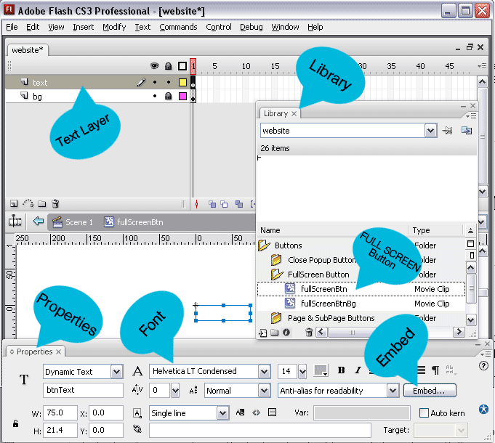

Volume button
open the volume button folder and edit the volumeBtn movieclip the text layer has been left unlocked and you can change the font and embedd special characters with the properties panel.
(* this button will not appear in your template if you have disabled the mp3 player in the audio settings)

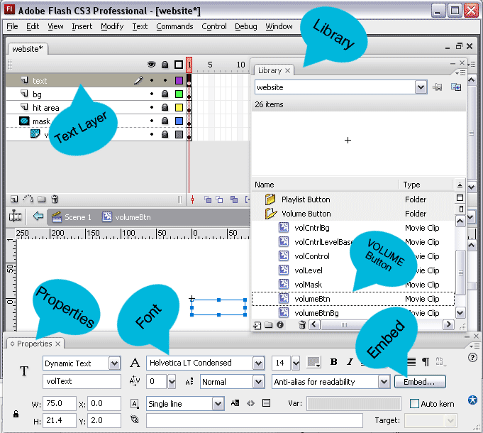

Playlist button
open the playlist button folder and edit the playlistBtn movieclip the text layer has been left unlocked and you can change the font and embedd special characters with the properties panel.
(* this button will not appear in your template if you have disabled the mp3 player in the audio settings)

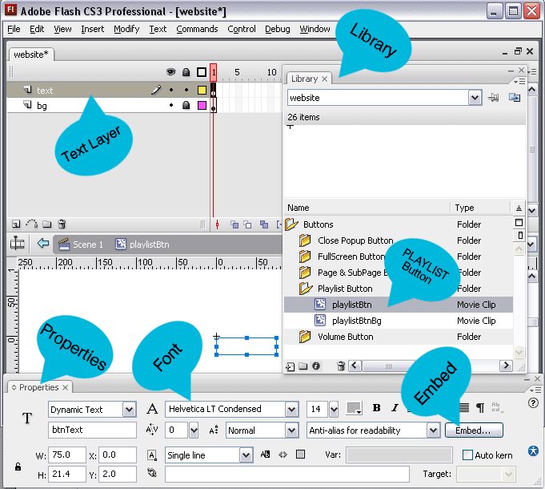

PAGE BUTTONS
Your buttons X & Y positioning as they sit within your header
(*we added some nice options here, check it out in the xml)
Width is deteremined by the length of the text of your page name,
vs having lets say a static width of 100 pixels and then you have one page named
HOME and another page named INTERNATIONAL DEVELOPMENT. Obviously
the home button would look way to big for such a small amount of text, and the text for the international development button wouldn't even fit inside the button.
The <addToBtnWidth> xml option lets you specify the number of pixels you want to add to the size of the button besides the actual text width.
You can also specify your page buttons Height, Space between buttons, button opacity, textfield position on the button, text field y (which allows you to control the vertical alignment of the text on your button) Font Size, Background Color, Text Color, Over State Bg Color, Over State Text Color, Clicked Background Color, & Clicked Text Color.

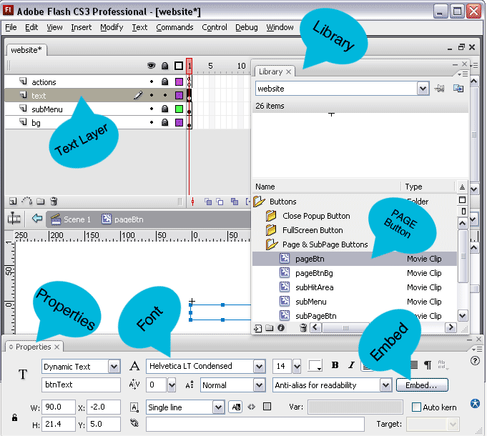

SUB-PAGE BUTTONS
All of the same features you can edit from config.xml for your page buttons you can also do for the subpage buttons, except the width is a static width you can edit inside XML. Simply because it does not look right with staggering sub page button widths.

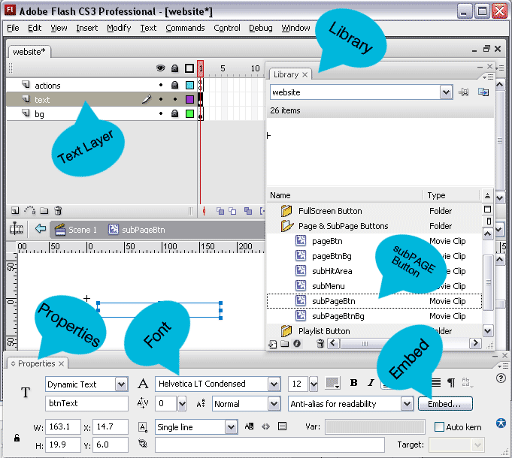

BACKGROUND PRE-LOADER
This preloader shows up when you load a page with a different type background ( you can choose from tiledImage, fullScreenImage, swfBackground, or flvBackground. There is more documentation on that further down in this help file.

You can set the X, Y for this button from XML.

If you want to change the font for this background preloader or add special characters, open backgroundModule.fla located in the SourceFiles folder. There is only one movieclip inside the library named backgroundPreloader. The text layer has been left unlocked and you can change the font and embedd special characters with the properties panel.

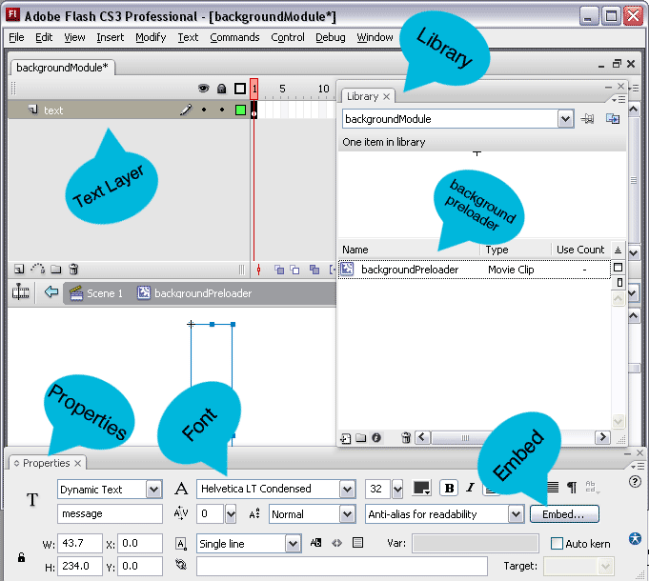

POPUP SETTINGS
These setting dimScreenColor and dimScreenOpacity are used if you have enabled the mp3 player under audio settings and someone clicks the playlist button, it is the color and opacity of the dimming screen that animates under your mp3 player so it has focus. These settings are ignored if you have disabled the mp3 player.

ADDING PAGES
Underneath all these configuration settings are a bunch of page tags.
A page tag simply means this:
<page>
</page>
where the first line <page> opens the tag
and the second line </page> closes the tag.

All of these page tags are looped through in order when your page buttons are created for your flash template. So the first page tag will be your first page button, your second page tag will be your second page, etc etc.

Inside of your page tag you will find a name tag
or <name> </name>
Whatever you put inside of here will show up on your address bar
Example
http://www.yourwebsite.com/#/home page
and will show up on your main page button in the text field

A new feature we added was the ability to have pages that don't show up in your menu,
to do this simply add this to your page tag.
<nonIndexedPage>true</nonIndexedPage>
(** make sure that any page tags that are nonIndexedPages do not have sub pages, you need to create an individual page tag for every nonIndexedPage you want to add. Also it doesnt matter what order you put these page tags in, as buttons are not created when flash is looping through the page tags and creating buttons, but for organizational sake I found it easier to put them at the bottom of the page tags.

The has sub pages tag is set to false for single page tags that you do not want sub pages for.
<hasSubPages>false</hasSubPages>

The new title tag is used for deep linking and shows up in the tile bar for your page
<title>PUT WHATEVER YOU WANT YOUR BROWSER PAGE TITLE TO READ HERE</title>

The xml path tag is the xml location for your pages xml file
<xmlPath>site_configuration/nonIndexedPage.xml</xmlPath>

The css path tag is the css location of the style sheet used to style the html text on that page
<cssPath>site_stylesheets/content.css</cssPath>

The utility type tag is the type of module the page should be, here are your options:
<utilityType>content</utilityType>
<utilityType>photos</utilityType>
<utilityType>videoGallery</utilityType>
<utilityType>slideshow</utilityType>
<utilityType>contact</utilityType>
<utilityType>link</utilityType>
<utilityType>externalSwf</utilityType>

The mute audio is a new tag we added which allows you to choose to mute the mp3 for any page you load except a page or sub page that opens up an external url
<muteAudio>false</muteAudio>

The backgroundOptions tag is a new feature with several tags within it.

ADDING A TILED BACKGROUND TO YOUR PAGE
Here is an xml example for how to use a tiled background image for your page
<backgroundOptions>
<topMargin>0</topMargin>
<bottomMargin>0</bottomMargin>
<useImage>true</useImage>
<imageURL>site_images/backgroundImages/woodPattern.jpg</imageURL>
<tileImage>true</tileImage>
<fullScreenImage>false</fullScreenImage>
</backgroundOptions>

ADDING A FULL SCREEN IMAGE BACKGROUND TO YOUR PAGE
Here is an xml example for how to use a full screen image background image for your page

<backgroundOptions>
<topMargin>0</topMargin>
<bottomMargin>0</bottomMargin>
<useImage>true</useImage>
<imageURL>site_images/backgroundImages/fullScreenImage.jpg</imageURL>
<tileImage>false</tileImage>
<fullScreenImage>true</fullScreenImage>
</backgroundOptions>

ADDING A SOLID COLOR BACKGROUND TO YOUR PAGE
Here is an xml example for how to use a solid color background image for your page
<backgroundOptions>
<topMargin>0</topMargin>
<bottomMargin>0</bottomMargin>
<useImage>true</useImage>
<imageURL>site_images/backgroundImages/solidGray.gif</imageURL>
<useBackgroundOverlay>false</useBackgroundOverlay>
<overlayURL>site_images/bgOverlay.png</overlayURL>
<tileImage>true</tileImage>
<fullScreenImage>false</fullScreenImage>
</backgroundOptions>

ADDING A SWF BACKGROUND TO YOUR PAGE
Here is an xml example for how to use a swf background image for your page
<backgroundOptions>
<topMargin>0</topMargin>
<useSwf>true</useSwf>
<swfURL>bgSWF.swf</swfURL>
</backgroundOptions>

(* if you decide to use a swf for your pages background then it needs to be an as3 swf, and you need to include a function in the actionscript of the first frame of the fla named destroySwf() which removes the background swf from the stage when another page with a different background is called. You can open up the fla bgSWF located in the source folder to see how this is done. The function starts on line 67 and looks like this:
function destroySwf():void{
//remove event listeners this swf added to the stage
stage.removeEventListener(Event.ENTER_FRAME, hoverScroll);
stage.removeEventListener(Event.RESIZE,resizeHandler);

//remove children
while(this.numChildren > 0){
this.removeChildAt(0);
}

//remove this swf from the stage
this.parent.removeChild(this);
}

ADDING A VIDEO BACKGROUND TO YOUR PAGE
Here is an xml example for how to use a video background image for your page
<backgroundOptions>
<topMargin>0</topMargin>
<bottomMargin>0</bottomMargin>
<useImage>false</useImage>
<useSwf>false</useSwf>
<useVideo>true</useVideo>
<useBackgroundOverlay>false</useBackgroundOverlay>
<overlayURL>site_images/patterns/bgOverlay.png</overlayURL>
<flvURL>site_videos/reflectors.flv</flvURL>
<flvOpacity>1</flvOpacity>
<bufferTime>2</bufferTime>
<loop>true</loop>
<smoothVideo>false</smoothVideo>
</backgroundOptions>

ADDING PAGES WITH SUB PAGES
A page with subpages is created pretty much the same way as a regular page, except nested with the page tags, you have sub page tags.

<page>
<name>CONTENT</name>
<hasSubPages>true</hasSubPages>

<!--First Sub Page -->
<subPage>
<name>LAYOUT STYLE 1</name>
<title>Content Module Layout Style One</title>
<xmlPath>site_configuration/homePage.xml</xmlPath>
<cssPath>site_stylesheets/content.css</cssPath>
<utilityType>content</utilityType>
<muteAudio>false</muteAudio>
<backgroundOptions>
<topMargin>0</topMargin>
<bottomMargin>0</bottomMargin>
<useImage>true</useImage>
<imageURL>site_images/yourImage.jpg</imageURL>
<tileImage>true</tileImage>
<fullScreenImage>false</fullScreenImage>
</backgroundOptions>
</subPage>

<!--Second Sub Page -->
<subPage>
<name>LAYOUT STYLE 2</name>
<title>Content Module Layout Style Two</title>
<xmlPath>site_configuration/layout2.xml</xmlPath>
<cssPath>site_stylesheets/content.css</cssPath>
<utilityType>content</utilityType>
<muteAudio>false</muteAudio>
<backgroundOptions>
<topMargin>0</topMargin>
<bottomMargin>0</bottomMargin>
<useImage>true</useImage>
<imageURL>site_images/yourImage.jpg</imageURL>
<tileImage>true</tileImage>
<fullScreenImage>false</fullScreenImage>
</backgroundOptions>
</subPage>
</page>

HOW TO ADD A CONTENT MODULE PAGE
(*you can create as many content pages as you like, just create a page tag for each one in config.xml and open any one of the content page xml files and save it as a new xml file with whatever nameyoulike.xml)

<page>
<name>CONTENT</name>
<hasSubPages>false</hasSubPages>
<title>Content Module Layout Style One</title>
<xmlPath>site_configuration/layout2.xml</xmlPath>
<cssPath>site_stylesheets/content.css</cssPath>
<utilityType>content</utilityType>
<muteAudio>false</muteAudio>
<backgroundOptions>
<topMargin>0</topMargin>
<bottomMargin>0</bottomMargin>
<useImage>true</useImage>
<imageURL>site_images/backgroundImages/woodPattern.jpg</imageURL>
<tileImage>true</tileImage>
<fullScreenImage>false</fullScreenImage>
</backgroundOptions>
</page>

CONTENT MODULE FEATURES BROKEN DOWN

* open layout2.xml and follow along with this help documentation or read all of the comments made on layout2.xml

The first configuration setting for your content page is the top margin, set this to however many pixels from the top you want your content page to start
<topMargin>140</topMargin>

Bottom Margin is just how many pixels from the bottom you want your content to stop, this all depends on the size of your footer you set in config.xml
<bottomMargin>50</bottomMargin>

read the comments in the xml for alignX and alignY *this is a very nice new feature
<alignX>center</alignX><!--Horizontal Alignment-->
<alignY>center</alignY><!-- Vertical Alignment-->

Set your content pages width / height / color and opacity here
<contentWidth>709</contentWidth>
<contentHeight>1964</contentHeight>
<contentBgColor>0x0c0c0c</contentBgColor>
<contentBgOpacity>1</contentBgOpacity>

Select the type of scrolling to use *nice new feature!
<useHoverScroll>false</useHoverScroll>
<useManualScroll>true</useManualScroll>

Skin Your Scroll Bar Features
*these settings apply if useManualScroll is true and useHoverScroll is false
<scrollBarWidth>15</scrollBarWidth>
<scrollBarHeight>200</scrollBarHeight>
<scrollBaseColor>0x000000</scrollBaseColor>
<addTiledPatternToScrollBase>true</addTiledPatternToScrollBase>
<patternUrl>site_images/patterns/edgePattern.png</patternUrl>
<scrollBaseOpacity>.67</scrollBaseOpacity>
<scrollerColor>0xcfcfcf</scrollerColor>
<scrollerOpacity>1</scrollerOpacity>

Used for pop up content
<dimWallPaperColor>0xffffff</dimWallPaperColor>
<dimWallPaperAlpha>.85</dimWallPaperAlpha>

Set the size of the font used in the image preloader if you load any super size images as a click event for your image, explained below under 10 click events for your images
<preloaderTextSize>140</preloaderTextSize>
Set the color of the font used in the image preloader
<preloaderTextColor>0x000000</preloaderTextColor>
Set the opacity of the font used in the image preloader
<preloaderTextOpacity>1</preloaderTextOpacity>

Font used for this image preloader is Helvetica LT Light
It is not a cheap font, but one of my favorites if you don't already have it as part of your collection, it can be purchased from linotype here for $26 dollars.
http://www.linotype.com/526/helvetica-family.html

If you want to change the font for this preloader or add special characters, open contentModule.fla located in the SourceFiles folder. In the library open the preloaders folder and then the bigPercentagePreloader movieclip the text layer has been left unlocked and you can change the font and embedd special characters with the properties panel.

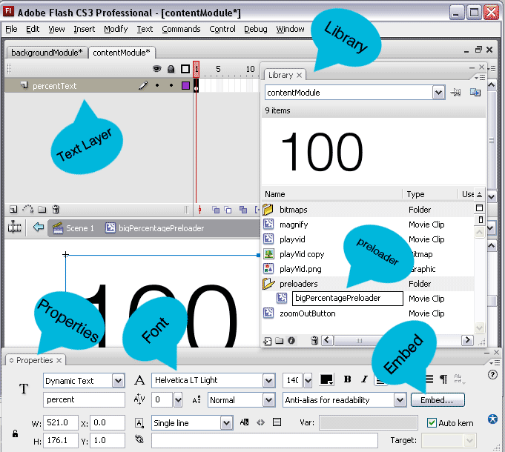

*THESE ARE IMPORTANT SETTINGS
Set this to true if your content page will display any images
<displayImages>true</displayImages>
Set this to true if your content page will display any html text blocks
<displayHtmlArticles>true</displayHtmlArticles>
Set this to true if your content page will include a slideshow
<displaySlideShow>true</displaySlideShow>
Set this to true if your content page will be including any external swfs
<displaySWF>true</displaySWF>

HOW TO ADD A SLIDESHOW TO YOUR CONTENT PAGE
*make sure displaySlideShow is set to true in your configuration
on the content pages xml. You can add 1 slideshow to each content page
<slideShow>
<x>41</x>
<y>54</y>
<xmlURL>site_configuration/layout2SlideShow.xml</xmlURL>
<cssURL>site_stylesheets/slideShow.css</cssURL>
</slideShow>

*open up layout2SlideShow.xml to see the xml settings for a slideshow
(you can add one slideshow to each content page)

HOW TO ADD A EXTERNAL SWF TO YOUR CONTENT PAGE
*make sure displaySWF is set to true in your configuration
on the content pages xml. You can add as many external swfs as you want,
just make sure they are all wrapped inside one swfs tag. Also make sure
they are as3 swfs, if you have an as2 swf you want to integrate and don't have the technical expertise to write the actionscript to do it, contact us from our profile page on the den and we will give you a quote, our hourly programming rate is $50/hour and subject to availability.

<swfs>
<swf>
<x>604</x>
<y>421</y>
<swfUrl>portSwf.swf</swfUrl>
<useFunctionForGarbageCollection>true</useFunctionForGarbageCollection>
<functionName>destroySwf</functionName>
</swf>

<!-- if you want to add multiple swfs just add another swf tag here inside of the <swfs> tag like this, dont try and load the same swf twice of flash will bomb on you though-->
<swf>
<x>604</x>
<y>421</y>
<swfUrl>yourswf.swf</swfUrl>
<useFunctionForGarbageCollection>true</useFunctionForGarbageCollection>
<functionName>destroySwf</functionName>
</swf>

</swfs>

It is highly recommended that when unloading your external swf, that any and all event listeners that have been set be removed, and all objects are removed from the stage, and bitmap data is disposed of. This clears your visitors memory and prevents your template from running into errors that can arise from unremoved event listeners. If you are flash beginner set the following <useFunctionForGarbageCollection> to false, if you are somewhat good with actionscript set the following <useFunctionForGarbageCollection> to true and then include the name of the function that takes care of removing your movieclip assets from memory. Make sure that this function is located on the first frame of the external swf that you are loading.

HOW TO ADD A HTML TEXT BLOCK TO YOUR CONTENT PAGE
*make sure displayHtmlArticles is set to true in your configuration on the content pages xml

You can add and position as many html text blocks as you want to each content page, just create a new article tag for each text block you want to add, the html text that is wrapped inside of the cdata tag is styled with the external .css file attached to the page from config.xml. So if your page tag looks like this:
<page>
<name>CONTENT</name>
<hasSubPages>false</hasSubPages>
<title>Content Module Layout Style One</title>
<xmlPath>site_configuration/homePage.xml</xmlPath>
<cssPath>site_stylesheets/content.css</cssPath>
<utilityType>content</utilityType>
</page>

then site_stylesheets/content.css is the style sheet you would use to style the fonts and colors of your html text.
Here is how you add a html text block to your content page.

<article>
<x>255</x>
<y>1428</y>
<width>167</width>
<articleText><![CDATA[<p>your html text goes here</p>
<a href="event:NON INDEXED PAGE">Text Link</a>]]>
</articleText>
</article>

You can also link to internal pages from your text by including an a tag like this one, inside your cdata tag.
<a href="event:NON INDEXED PAGE">Text Link</a>

HOW TO ADD AN IMAGE TO YOUR CONTENT PAGE
*make sure displayImages is set to true in your configuration on the content pages xml
You can add and position as many images as you want to each content page, just create a new image tag for each image you want to add. Also do not load more than one instance of an image, the images are preloaded with a bulkloader and if you try and load the same image twice in seperate tags you will make the page bomb, or incorrectly display your images.

<image>
<x>42</x>
<y>405</y>
<imageURL>site_images/pages/layout2/title.png</imageURL>
</image>

10 CLICK EVENTS FOR YOUR IMAGES
below I will include examples of how to create an image tag for each of these 10 possible click events.

1
Eg of how to link an image to a photogallery popup
<image>
<x>39</x>
<y>532</y>
<imageURL>site_images/pages/layout2/layout2_09.png</imageURL>
<addPhotoPopUp>true</addPhotoPopUp>
<photoXmlUrl>site_configuration/photoGalleryPopUp.xml</photoXmlUrl>
<photoCssUrl>site_stylesheets/photo.css</photoCssUrl>
</image>

2
Eg of how to link an image to a video gallery popup
<image>
<x>255</x>
<y>532</y>
<imageURL>site_images/pages/layout2/layout2_11.png</imageURL>
<addVideoPopUp>true</addVideoPopUp>
<videoXmlUrl>site_configuration/16x9videoGallery.xml</videoXmlUrl>
<videoCssUrl>site_stylesheets/videoGalleryStyle.css</videoCssUrl>
</image>
When you hover over an image with a videopopup image click event added to it you will get a little image of a play video icon that appears. This image is located in the site_images folder and can be edited by simply replacing this play video icon with your own.
The name of the image is playVid.png *make sure you use the exact same image name playVid.png

3
Eg of how to link an image to a content page popup
<image>
<x>471</x>
<y>532</y>
<imageURL>site_images/pages/layout2/layout2_13.png</imageURL>
<addContentPopUp>true</addContentPopUp>
<contentPopUpXmlUrl>site_configuration/contentPopUp.xml</contentPopUpXmlUrl>
<contentPopUpCssUrl>site_stylesheets/content.css</contentPopUpCssUrl>
</image>

4
Eg of loading a super-sized image pop-up
<image>
<x>39</x>
<y>890</y>
<imageURL>site_images/pages/layout2/layout2_37.png</imageURL>
<addSuperSizedImagePopUp>true</addSuperSizedImagePopUp>
<superSizedImageUrl>site_images/image.jpg</superSizedImageUrl>
</image>

When you hover over an image with a super-sized image click event added to it you will get a little image of a magnifying glass that appears. This image is located in the site_images folder and can be edited by simply replacing this magnifying glass icon with your own.
The name of the image is magnifying.png *make sure you use the exact same image name magnifying.png

When the image is clicked and the supersized version is loaded you will get a zoom out icon, this image can be changed by swapping out the zoomOut.png image icon located in the site_images folder *make sure you use the exact same image name zoomOut.png

5
Eg of loading a single video pop-up
<image>
<x>255</x>
<y>890</y>
<imageURL>site_images/pages/layout2/layout2_39.png</imageURL>
<addVideoPopUp>true</addVideoPopUp>
<videoXmlUrl>site_configuration/singleVideo.xml</videoXmlUrl>
<videoCssUrl>site_stylesheets/videoGalleryStyle.css</videoCssUrl>
</image>
When you hover over an image with a videopopup image click event added to it you will get a little image of a play video icon that appears. This image is located in the site_images folder and can be edited by simply replacing this play video icon with your own.
The name of the image is playVid.png *make sure you use the exact same image name playVid.png

6
Eg of loading a slideshow pop-up
<image>
<x>471</x>
<y>890</y>
<imageURL>site_images/pages/layout2/layout2_41.png</imageURL>
<addSlideshowPopUp>true</addSlideshowPopUp>
<slideShowXmlUrl>site_configuration/slideShow2.xml</slideShowXmlUrl>
<slideShowCssUrl>site_stylesheets/slideShow.css</slideShowCssUrl>
</image>

7
Eg of linking your image to an external-swf
<image>
<x>39</x>
<y>1248</y>
<imageURL>site_images/pages/layout2/layout2_65.png</imageURL>
<addExternalSwfPopUp>true</addExternalSwfPopUp>
<muteAudio>true</muteAudio>
<swfUrl>as3swf.swf</swfUrl>
<useFunctionForGarbageCollection>true</useFunctionForGarbageCollection>
<functionName>destroySwf</functionName>
<useTemplateToCenterSwf>true</useTemplateToCenterSwf>
<swfWidth>916</swfWidth>
<swfHeight>357</swfHeight>
</image>

It is highly recommended that when unloading your external swf, that any and all event listeners that have been set be removed, and all objects are removed from the stage, and bitmap data is disposed of. This clears your visitors memory and prevents your template from running into errors that can arise from unremoved event listeners. If you are flash beginner set the following <useFunctionForGarbageCollection> to false, if you are somewhat good with actionscript set the following <useFunctionForGarbageCollection> to true and then include the name of the function that takes care of removing your movieclip assets from memory. Make sure that this function is located on the first frame of the external swf that you are loading.
8
Eg of linking your image to a non-indexed page,
or a page that IS NOT part of your page/subpage buttons

<image>
<x>255</x>
<y>1248</y>
<imageURL>site_images/pages/layout2/layout2_67.png</imageURL>
<addInternalPageLink>true</addInternalPageLink>
<pageName>NON INDEXED PAGE</pageName>
</image>

9
Eg of linking your image to an indexed page, or a page that IS part of your page/subpage buttons

(* if you are linking to a page with sub pages you do it like this, inside of the pageName tag you put what ever is in the name tag of your page tag in config.xml then add a / and then put whatever is in the name tag of your subpage. So if you are linking to your content page and the layout style 1 sub page, you do it like this CONTENT/LAYOUT STYLE 1
)
<image>
<x>471</x>
<y>1248</y>
<imageURL>site_images/pages/layout2/layout2_69.png</imageURL>
<addInternalPageLink>true</addInternalPageLink>
<pageName>CONTENT/LAYOUT STYLE 1</pageName>
</image>

(* if you are linking to a page with NO subpages you do it like this, inside of the pageName tag you put what ever is in the name tag of your page tag in config.xml)
<image>
<x>471</x>
<y>1248</y>
<imageURL>site_images/pages/layout2/layout2_69.png</imageURL>
<addInternalPageLink>true</addInternalPageLink>
<pageName>CONTACT</pageName>
</image>

10
Eg of how to link an image to an external url
<image>
<x>39</x>
<y>1609</y>
<imageURL>site_images/pages/layout2/layout2_93.png</imageURL>
<addLink>true</addLink>
<linkUrl>http://activeden.net/user/FLASHdriven/portfolio</linkUrl>
<linkOpenType>_blank</linkOpenType>
<!-- or use _self to open up links in same window-->
</image>

EDITING YOUR PRELOADER

How to edit.

Preloader.fla is in the SourceFiles folder, if you want to edit the preloader open preloader.fla located in the SourceFiles folder. It is a very simple movieclip. I included a screenshot of it below. If you want to change the color of the progress bar open the glow movieclip in the flash library and with the properties panel change its color and opacity there. The font used is kroeger 05_55 it is 10bucks and can be purchased here http://www.miniml.com/fonts/ it is a nice clean font that looks real good small. If you want to change the font to one you own, open the preloader movieclip inside the flash library. Both text layers have been unlocked. The text that contains the loading message is on the message layer, and the percentage number is located on the percentage layer. By default the preloader is centered in the middle of your screen, if you want to change its positioning you will need to edit the actionscript on the first frame of Scene1 or the main timeline.
Lines 29 & 30
preload.x = Math.round((StageWidth/2) - (preload.width/2));
preload.y = Math.round((StageHeight/2) – (preload.height/2));
and also in the reposition preloader function
Lines 94-95
preload.x = Math.round((StageWidth/2) - (preload.width/2));
preload.y = Math.round((StageHeight/2) – (preload.height/2));

If you change the positioning of your preloader you will need to recompile the movieclip by holding the controlKey down and hitting enter, or going to control then test movie.

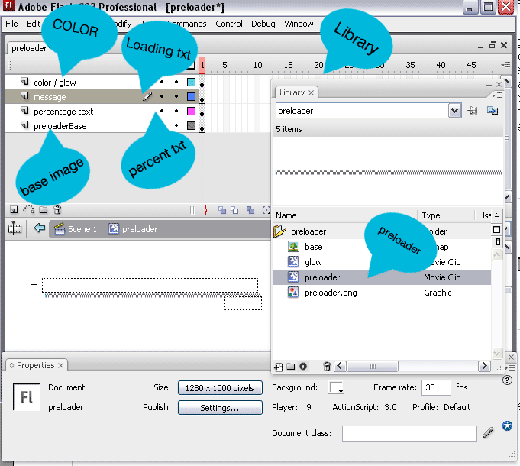

HOW TO ADD A PHOTO MODULE PAGE
(*you can create as many photo module pages as you like, just create a page tag or subpage tag for each one in config.xml and open any one of the photo module xml files and save it as a new xml file with whatever nameyoulike.xml)
For this example open photoGallery.xml located in the site_configuration and follow along with this tutorial on how to modify your photo gallery.

The fifth page tag down in config.xml is a great example of how to load a photo module page, here is the xml from config.xml in the site_configuration folder.
<page>
<name>PHOTOS</name>
<hasSubPages>false</hasSubPages>
<title>The Edge Photo Module Gallery</title>
<xmlPath>site_configuration/photoGallery.xml</xmlPath>
<cssPath>site_stylesheets/photo.css</cssPath>
<utilityType>photos</utilityType>
<muteAudio>false</muteAudio>
<backgroundOptions>
<topMargin>0</topMargin>
<bottomMargin>0</bottomMargin>
<useImage>true</useImage>
<imageURL>site_images/backgroundImages/solidGray.gif</imageURL>
<useBackgroundOverlay>false</useBackgroundOverlay>
<overlayURL>site_images/bgOverlay.png</overlayURL>
<tileImage>true</tileImage>
<fullScreenImage>false</fullScreenImage>
</backgroundOptions>
</page>

Make sure you open photoGallery.xml and follow along, or just read all the comments made in photoGallery.xml

PHOTO MODULE CONFIGURATION OPTIONS

choose if you want to include tooltips when you hover over thumbnails
<showThumbToolTips>true</showThumbToolTips>

set the top margin for your photo gallery
<topMargin>75</topMargin>

set the bottom margin for your photo gallery
<bottomMargin>0</bottomMargin>

set the border width you would like to surround your large images
<imageBorderWidth>0</imageBorderWidth>

set the color of the rectangle under your large images, this is the frame that is visible underneath your image when preloading the next image
<imageBorderColor>0x0c0c0c</imageBorderColor>

set the opacity of the rectangle under your large images
<imageBorderOpacity>1</imageBorderOpacity>

set the size of the font used in the image preloader
<preloaderTextSize>140</preloaderTextSize>

set the color of the font used in the image preloader
<preloaderTextColor>0x00b7dc</preloaderTextColor>

set the opacity of the font used in the image preloader
<preloaderTextOpacity>1</preloaderTextOpacity>

set the color and opacity for your forward and reverse buttons
<frwdRevBtnColor>0x0c0c0c</frwdRevBtnColor>
<frwdRevBtnOpacity>1</frwdRevBtnOpacity>
<frwdRevArrowColor>0x00b7dc</frwdRevArrowColor>

set the color and opacity for your fullscreen image button
<fsBtnColor>0x0c0c0c</fsBtnColor>
<fsBtnOpacity>1</fsBtnOpacity>
<fsIconColor>0x00b7dc</fsIconColor>

set the color and opacity for your image info button
<infoBtnColor>0x0c0c0c</infoBtnColor>
<infoIconColor>0x00b7dc</infoIconColor>
<infoBtnOpacity>1</infoBtnOpacity>

Choose the scroll type for your information pop-up
<useHoverScroll>true</useHoverScroll>
<useManualScroll>false</useManualScroll>

These settings apply if useManualScroll is true and useHoverScroll is false
<scrollBarWidth>19</scrollBarWidth>
<scrollBarHeight>200</scrollBarHeight>
<scrollBaseColor>0xffffff</scrollBaseColor>
<addTiledPatternToScrollBase>false</addTiledPatternToScrollBase>
<patternUrl>site_images/patterns/edgePattern.png</patternUrl>
<scrollBaseOpacity>1</scrollBaseOpacity>
<scrollerColor>0x0c0c0c</scrollerColor>
<scrollerOpacity>1</scrollerOpacity>

set the color, opacity, and text color for your thumbnail tooltips
these tooltip settings will be ignored if <showThumbToolTips> is set to false
<tooltipColor>0x0c0c0c</tooltipColor>
<tooltipOpacity>1</tooltipOpacity>
<tooltipTextColor>0x00b7dc</tooltipTextColor>
set the color and opacity that is used when your screen is dimmed
<dimBgColor>0xFFFFFF</dimBgColor>
<dimBgOpacity>.85</dimBgOpacity>

point this tag to an image url for a close button
<closeBtnImageUrl>site_images/pages/photoGallery/infoCloseBtn.gif</closeBtnImageUrl>

EDITING THE FONT FOR THE IMAGE PRELOADER
Font used for this image preloader is Helvetica LT Light
It is not a cheap font, but one of my favorites if you don't already have it as part of your collection, it can be purchased from linotype here for $26 dollars.
http://www.linotype.com/526/helvetica-family.html

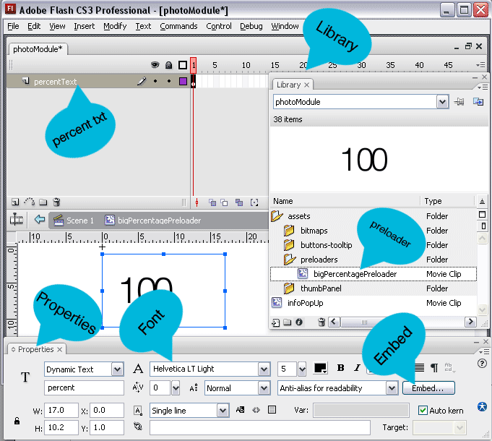
If you want to change the font for this preloader or add special characters, open photoModule.fla located in the SourceFiles folder. In the library open the assets folder and then the preloaders folder and then the bigPercentagePreloader movieclip the text layer has been left unlocked and you can change the font and embedd special characters with the properties panel.

EDITING OTHER PHOTO MODULE OPTIONS THAT ARE NOT PART OF THE XML CONFIGURATION SETTINGS. LIKE CHANING ICONS.

If you want to change icons or anything else that is not part of the xml configuration settings, open photoModule.fla located in the SourceFiles folder. In the library open the assets folder and then the buttons-tooltip folder and edit these movieclips and graphics. You will need to be somewhat ok with flash to edit these icons.

HOW TO ADD AN IMAGE TO YOUR PHOTO GALLERY PAGE
Create an image tag like this. All image tags are looped throug in order, so your first image that shows up in your gallery will be the first image in your xml file.

<image>
<ThumbUrl>site_images/pages/photoGallery/02_thumb.jpg</ThumbUrl>
<ImageUrl>site_images/pages/photoGallery/02_full.jpg</ImageUrl>
<thumbCaption>Set tooltip color from XML</thumbCaption>
<addFullScreenButton>true</addFullScreenButton>
<addImageInfo>false</addImageInfo>
</image>

HOW TO INCLUDE A SUPERSIZED VERSION OF YOUR IMAGE
Your images are automatically scaled to fit within the top margin and bottomMargin you set at the top of the configuration. So if you set <addFullScreenButton>true</addFullScreenButton>
then when the fullscreen icon is clicked the image will be blown up to its full size and if the image is larger than the user's fullscreen size, the image will automatically scroll left to right and up and down. To disable this feature on any image set addFullScreenButton to false.

HOW TO ADD AN IMAGE INFO POPUP
Simply set the <addImageInfo> tag to true
and add these tags to your image tage
You can add unlimited images withing your image info popup just like the content module except you don't have all the image click events you have with the content module.
You can also add unlimited html text blocks.

<infoPopUp>
<width>440</width>
<height>1500</height>
<bgClr>0xFFFFFF</bgClr>
<bgOpac>1</bgOpac>
<addImages>true</addImages>
<addHtml>true</addHtml>
<image>
<x>37</x>
<y>27</y>
<imageURL>site_images/pages/photoGallery/infoTitle.png</imageURL>
</image>
<image>
<x>36</x>
<y>131</y>
<imageURL>site_images/pages/photoGallery/infoSubTitle.png</imageURL>
</image>
<textBlock>
<x>41</x>
<y>250</y>
<width>520</width>
<articleText><![CDATA[<h4>PUT YOUR HTML TEXT INSIDE HERE, IT IS STYLED WITH THE STYLE SHEET YOU ATTACHED TO YOUR PHOTOGALLERY IN CONFIG.xml</h4>]]>
</articleText>
</textBlock>
</infoPopUp>

HOW TO CHANGE THE TOOTLIP TEXT OR ADD SPECIAL CHARACTERS

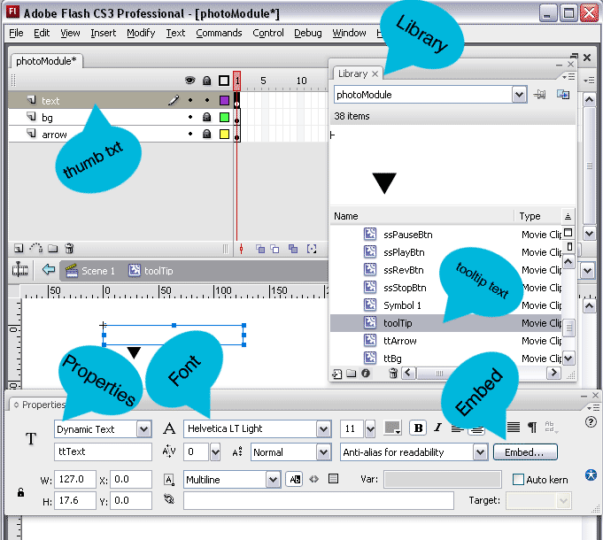

HOW TO ADD VIDEO PAGES

First of check out config.xml located in the site_configuration folder and check out the sixth page tag, there is an example of how to create a page for each one of these video module types.

HOW TO ADD A SINGLE VIDEO PAGE
*open singleVideo.xml and follow the seven steps outlined in the comments for skinning your single video player

Here is the xml pulled from config.xml on how to create a page that links to a single video

<!-- SINGLE VIDEO PAGE EXAMPLE -->
<subPage>
<name>SINGLE VIDEO PLAYER</name>
<title>The Edge Single Video Player</title>
<xmlPath>site_configuration/singleVideo.xml</xmlPath>
<cssPath>site_stylesheets/videoGalleryStyle.css</cssPath>
<utilityType>videoGallery</utilityType>
<muteAudio>true</muteAudio>
<backgroundOptions>
<topMargin>0</topMargin>
<bottomMargin>0</bottomMargin>
<useImage>true</useImage>
<imageURL>site_images/backgroundImages/woodPattern.jpg</imageURL>
<tileImage>true</tileImage>
<fullScreenImage>false</fullScreenImage>
</backgroundOptions>
</subPage>

HOW TO ADD A MINIMAL VIDEO GALLERY PAGE
*open minimalVideoModule.xml and follow the seven steps outlined in the comments for skinning your minimal video player

Here is the xml pulled from config.xml on how to create a page that links to a minimal video player

<!-- MINIMAL VIDEO PLAYER WITH THUMBNAILS AND ONE CATEGORY -->
<subPage>
<name>MINIMAL VIDEO GALLERY</name>
<title>The Edge Single Category Video Player with thumbnails</title>
<xmlPath>site_configuration/minimalVideoModule.xml</xmlPath>
<cssPath>site_stylesheets/videoGalleryStyle.css</cssPath>
<utilityType>videoGallery</utilityType>
<muteAudio>true</muteAudio>
<backgroundOptions>
<topMargin>0</topMargin>
<bottomMargin>0</bottomMargin>
<useImage>true</useImage>
<imageURL>site_images/backgroundImages/woodPattern.jpg</imageURL>
<tileImage>true</tileImage>
<fullScreenImage>false</fullScreenImage>
</backgroundOptions>
</subPage>

HOW TO ADD A 4x3 VIDEO GALLERY PAGE
*open 4x3videoGallery.xml and follow the nine steps outlined in the comments for skinning your 4x3 video player

Here is the xml pulled from config.xml on how to create a page that links to a 4x3 video player

<subPage>
<name>FULL VIDEO GALLERY 4x3</name>
<title>The Edge 4x3 Video Gallery</title>
<xmlPath>site_configuration/4x3videoGallery.xml</xmlPath>
<cssPath>site_stylesheets/videoGalleryStyle.css</cssPath>
<utilityType>videoGallery</utilityType>
<muteAudio>true</muteAudio>
<backgroundOptions>
<topMargin>0</topMargin>
<bottomMargin>0</bottomMargin>
<useImage>true</useImage>
<imageURL>site_images/backgroundImages/woodPattern.jpg</imageURL>
<tileImage>true</tileImage>
<fullScreenImage>false</fullScreenImage>
</backgroundOptions>
</subPage>

HOW TO ADD A 16x9 VIDEO GALLERY PAGE
*open 16x9videoGallery.xml and follow the nine steps outlined in the comments for skinning your 16x9 video player

Here is the xml pulled from config.xml on how to create a page that links to a 16x9 video player

<subPage>
<name>FULL VIDEO GALLERY 16x9</name>
<title>The Edge 16x9 Video Gallery</title>
<xmlPath>site_configuration/16x9videoGallery.xml</xmlPath>
<cssPath>site_stylesheets/videoGalleryStyle.css</cssPath>
<utilityType>videoGallery</utilityType>
<muteAudio>true</muteAudio>
<backgroundOptions>
<topMargin>0</topMargin>
<bottomMargin>0</bottomMargin>
<useImage>true</useImage>
<imageURL>site_images/backgroundImages/woodPattern.jpg</imageURL>
<tileImage>true</tileImage>
<fullScreenImage>false</fullScreenImage>
</backgroundOptions>
</subPage>

HOW TO ADD A VIDEO TO YOUR SINGLE VIDEO PAGE
here is the xml structure for a single video, pulled from singlevideo.xml
*since the same module is used for all 4 video player types your single video is wrapped in a categories and category tag, even though you can only have one video in a single video page.

<categories>
<category>
<video>
<videoUrl>site_videos/Elements/prometheus.flv</videoUrl>
<autoStartVideo>true</autoStartVideo>
</video>
</category>
</categories>

HOW TO ADD VIDEOS TO YOUR MINIMAL VIDEO MODULE
here is the xml structure for adding videos to your minimal video module pulled from minimalVideoModule.xml
*you can have 1 category tag for a minimal video module, but unlimited videos within that one category.

<categories>
<category>
<!-- video 1-->
<video>
<videoUrl>site_videos/Elements/prometheus.flv</videoUrl>
<autoStartVideo>true</autoStartVideo>
<thumbImage>site_images/video/prometheusThumb.jpg</thumbImage>
<thumbDescription><![CDATA[<h1>Your Video Title Here</h1><p>This is HTML text that you can style with an external stylesheet. </p><a class="alt" target="_blank" href="http://activeden.net/user/FLASHdriven/portfolio">and add links</a>]]></thumbDescription>
</video>

<!-- video 2-->
<video>
<videoUrl>site_videos/Elements/AEelementsPackPromoFull.flv</videoUrl>
<autoStartVideo>true</autoStartVideo>
<thumbImage>site_images/video/packv1Thumb.jpg</thumbImage>
<thumbDescription><![CDATA[<h1>Your Video Title Here</h1><p>This is HTML text that you can style with an external stylesheet. </p><a class="alt" target="_blank" href="http://activeden.net/user/FLASHdriven/portfolio">and add links</a>]]></thumbDescription>
</video>
</category>
<categories>

HOW TO ADD VIDEOS TO YOUR 4x3 or 16x9 VIDEO MODULE
you add videos the same way for the 4x3 video gallery as you do the 16x9 video gallery.
Use 4x3videoGallery.xml if you want your video gallery to be in 4x3 mode and 16x9videoGallery.xml if you want your video gallery to be in 16x9 mode.
*you can have multiple categories and multiple videos within each category

HOW TO ADD A SLIDESHOW PAGE

Add a page tag like this one I pulled from config.xml it is the seventh page tag

<page>
<name>SLIDESHOW</name>
<hasSubPages>false</hasSubPages>
<title>The Edge Slideshow Module</title>
<xmlPath>site_configuration/slideShow.xml</xmlPath>
<cssPath>site_stylesheets/slideShow.css</cssPath>
<utilityType>slideshow</utilityType>
<muteAudio>false</muteAudio>
<backgroundOptions>
<topMargin>0</topMargin>
<bottomMargin>0</bottomMargin>
<useImage>true</useImage>
<imageURL>site_images/backgroundImages/solidBlack.gif</imageURL>
<useBackgroundOverlay>false</useBackgroundOverlay>
<overlayURL>site_images/bgOverlay.png</overlayURL>
<tileImage>true</tileImage>
<fullScreenImage>false</fullScreenImage>
</backgroundOptions>
</page>

open up slideShow.xml
it is straightforward, the slideshow configuration options are located at the top of the page
and then you add slide tags for each slide you want to add

<slide>
<url>site_images/pages/slideShow/slide10.gif</url>
<ImageTitle><![CDATA[<h1>Enable / Disable</h1><p>This Information Text from XML</p>]]></ImageTitle>
</slide>

html text inside of cdata tag is styled with the .css file that is attached in config.xml
in this case site_stylesheets/slideShow.css

HOW TO ADD AN EXTERNAL SWF AS A PAGE
*look at the eighth page tag down in config.xml

<page>
<name>EXTERNAL SWF</name>
<hasSubPages>false</hasSubPages>
<title>The Edge External AS3 Swf</title>
<muteAudio>false</muteAudio>
<backgroundOptions>
<topMargin>0</topMargin>
<bottomMargin>0</bottomMargin>
<useImage>true</useImage>
<imageURL>site_images/backgroundImages/woodPattern.jpg</imageURL>
<tileImage>true</tileImage>
<fullScreenImage>false</fullScreenImage>
</backgroundOptions>
<utilityType>externalSwf</utilityType>
<swfUrl>as3swf.swf</swfUrl>
<useFunctionForGarbageCollection>true</useFunctionForGarbageCollection>
<functionName>destroySwf</functionName>
<useTemplateToCenterSwf>true</useTemplateToCenterSwf>
<swfWidth>916</swfWidth>
<swfHeight>357</swfHeight>
</page>

It is highly recommended that when unloading your external swf, that any and all event listeners that have been set be removed, and all objects are removed from the stage, and bitmap data is disposed of. This clears your visitors memory and prevents your template from running into errors that can arise from unremoved event listeners. If you are flash beginner set the following <useFunctionForGarbageCollection> to false, if you are somewhat good with actionscript set the following <useFunctionForGarbageCollection> to true and then include the name of the function that takes care of removing your movieclip assets from memory. Make sure that this function is located on the first frame of the external swf that you are loading.

HOW TO ADD A CONTACT PAGE
*look at the nineth page tag down in config.xml here is a the xml

<page>
<name>CONTACT</name>
<hasSubPages>false</hasSubPages>
<title>The Edge Contact Module</title>
<xmlPath>site_configuration/contact.xml</xmlPath>
<cssPath>site_stylesheets/content.css</cssPath>
<utilityType>contact</utilityType>
<muteAudio>false</muteAudio>
<backgroundOptions>
<topMargin>0</topMargin>
<bottomMargin>0</bottomMargin>
<useImage>true</useImage>
<imageURL>site_images/backgroundImages/solidGray.gif</imageURL>
<useBackgroundOverlay>false</useBackgroundOverlay>
<overlayURL>site_images/bgOverlay.png</overlayURL>
<tileImage>true</tileImage>
<fullScreenImage>false</fullScreenImage>
</backgroundOptions>
</page>

CONTACT PAGE FEATURES
the contact module has all of the features of the content module, so if you need a refresher go up to the content module above and read through how to edit the content module. The fla is the same except it is named contact.fla and is located in the SourceFiles folder. If you need to change any of the text fields open contactModule.fla, edit your text fields and recompile/publish your swf.

There are a couple features in the contact module that the content module does not include.
* open up contact.xml and you will see that there are two images that look like this.

This is how you create a send button for your form
<image>
<x>572</x>
<y>365</y>
<imageURL>site_images/pages/contact/contact_76.png</imageURL>
<sendBtn>true</sendBtn>
</image>

This is how you create a clear button for your form
<image>
<x>619</x>
<y>365</y>
<imageURL>site_images/pages/contact/contact_77.png</imageURL>
<clearBtn>true</clearBtn>
</image>

HOW TO CUSTOMIZE YOUR NAME INPUT FIELD
<nameInputX>432</nameInputX>
<nameInputY>97</nameInputY>
<nameInputWidth>230</nameInputWidth>
<nameInputTextColor>0x474747</nameInputTextColor>
<nameInputTextFont>Arial</nameInputTextFont>
<nameInputTextSize>12</nameInputTextSize>

HOW TO CUSTOMIZE YOUR EMAIL INPUT FIELD
<emailInputX>432</emailInputX>
<emailInputY>139</emailInputY>
<emailInputWidth>230</emailInputWidth>
<emailInputTextColor>0x474747</emailInputTextColor>
<emailInputTextFont>Arial</emailInputTextFont>
<emailInputTextSize>12</emailInputTextSize>

HOW TO CUSTOMIZE YOUR MESSAGE INPUT FIELD
<messageInputX>455</messageInputX>
<messageInputY>180</messageInputY>
<messageInputWidth>210</messageInputWidth>
<messageInputTextColor>0x474747</messageInputTextColor>
<messageInputTextFont>Arial</messageInputTextFont>
<messageInputTextSize>12</messageInputTextSize>

HOW TO CUSTOMIZE YOUR RESPONSE TEXT FIELD\
<responseTextX>392</responseTextX>
<responseTextY>346</responseTextY>
<responseTextWidth>350</responseTextWidth>
<responseTextColor>0x00b7dc</responseTextColor>
<responseTextFont>Arial</responseTextFont>
<responseTextSize>12</responseTextSize>

HOW TO CONFIGURE MY EMAIL ADDRESS FOR FORM DELIVERY
*obviously your server must support php for this email script to work

open email.php in the siteconfiguration folder and edit these two variables
$yourEmailAddress = "youremail@gmail.com";
$yourWebAddress = "www.yourwebsite.com";

HOW TO CHANGE OUT THE MAP USED
the map was simply used by adding a swf to the contact page, the same way you add a swf to the content pages outlined above. You could very easily substitute this with a nice google map swf that you purchase from activeden, just make sure it is an as3 swf.

Or if you want to use the existing swf and just replace the map, first open contactMap.gif
located here: \site_images\pages\contact\contactMap.gif
update the image with your map and resave the gif, make sure it keeps the same file name and just replaces contactMap.gif then move externalMap.fla from the sourcefiles folder to the root directory and open in flash. Open the flash library, right click on the contactMap bitmap and go to update then update the image. Recompile your swf, and move contactModule.fla back to the source folder so that it doesn't get uploaded to your ftp server where it can be stolen.

HOW TO CREATE A PAGE THAT IS AN EXTERNAL LINK
*check out the second to last page tag in config.xml (this couldn't be easier)

<page>
<name>BLOG</name>
<hasSubPages>false</hasSubPages>
<title>LINK TO BLOG</title>
<utilityType>link</utilityType>
<externalURL>http://activeden.net/user/FLASHdriven/portfolio</externalURL>
</page>

HOW TO CREATE A PAGE THAT DOESNT SHOW UP IN THE PAGE BUTTONS
*check out the very last page tag in config.xml the only difference is that this page tag has a nonIndexedPage tag that is set to true, letting flash know not to index it with your page buttons. You must create an individual page tag for your non-indexed pages, setting a nonIndexedPage tag on a subpage will not work.

<page>
<nonIndexedPage>true</nonIndexedPage>
<hasSubPages>false</hasSubPages>
<name>NON INDEXED PAGE</name>
<title>The Edge NON INDEXED ARCHIVED PAGE</title>
<xmlPath>site_configuration/nonIndexedPage.xml</xmlPath>
<cssPath>site_stylesheets/content.css</cssPath>
<utilityType>content</utilityType>
<muteAudio>false</muteAudio>
<backgroundOptions>
<topMargin>0</topMargin>
<bottomMargin>0</bottomMargin>
<useImage>true</useImage>
<imageURL>site_images/backgroundImages/woodPattern.jpg</imageURL>
<tileImage>true</tileImage>
<fullScreenImage>false</fullScreenImage>
</backgroundOptions>
</page>

HOW TO EDIT MP3 PLAYER
*open music.xml and you have the ability to skin the followin features from XML

<!-- Background color -->
<bgColor>0x000000</bgColor>

<!-- CLOSE BUTTON -->
<closeBtnTxt>close</closeBtnTxt>
<closeBtnTxtClr>0x000000</closeBtnTxtClr>
<closeBtnTxtSize>24</closeBtnTxtSize>
<closeBtnX>330</closeBtnX>
<closeBtnY>-45</closeBtnY>

<!-- TIME BAR -->
<timeBarBgColor>0x0c0c0c</timeBarBgColor>
<elapsedTimeTxtColor>0xb7b7b7</elapsedTimeTxtColor>
<divider>0x555555</divider>
<totalTimeTxtColor>0x555555</totalTimeTxtColor>

<!-- VOLUME -->
<volumeBarColor>0x3e3e3e</volumeBarColor>
<volumeScrubberColor>0x9c9c9c</volumeScrubberColor>

<!-- CONTROLS -->
<playPauseClr>0x303030</playPauseClr>
<playPauseOverClr>0x00b7dc</playPauseOverClr>
<stopClr>0x303030</stopClr>
<stopOverClr>0x00b7dc</stopOverClr>
<reverseClr>0x303030</reverseClr>
<reverseOverClr>0x00b7dc</reverseOverClr>
<forwardClr>0x303030</forwardClr>
<forwardOverClr>0x00b7dc</forwardOverClr>

<!--Now Playing Track Info Layered on top of Album Art thumbnail-->
<nowPlayingTxtInfoClr>0xa5a5a5</nowPlayingTxtInfoClr>
<nowPlayingBgColor>0x000000</nowPlayingBgColor>

<!-- Playlist Track Button -->
<trackBgColor>0x060606</trackBgColor>
<trackOverBgColor>0x111111</trackOverBgColor>
<artistTextClr>0xa5a5a5</artistTextClr>
<titleTextClr>0xa5a5a5</titleTextClr>
<artistOverTextClr>0x00b7dc</artistOverTextClr>
<titleOverTextClr>0xa5a5a5</titleOverTextClr>

ADDING AN MP3 TO YOUR PLAYLIST

just add or remove a track tag in music.xml, songs are displayed in order, so the first track tag is the mp3 that will show up first in the mp3 player

<!-- SONG #1 -->
<track>
<artist>Soundroll</artist>
<album>Audio Jungle</album>
<title>Protest</title>
<url>mp3s/protest.mp3</url>
<thumb>site_images/music//album1_thumb.gif</thumb>
</track>

Sample watermarked tracks were provided courtesy of soundroll on audio jungle. If you like any of his songs, you can purchase them here.

http://audiojungle.net/user/soundroll

CHANGING THE EMBEDDED FONTS ON THE MP3 player

If you want to change any of the fonts used in the mp3 player or add special characters, open mp3Module.fla located in the SourceFiles folder. In the library open the mp3player movieclip all of the layers are neatly organized, just make sure you unlock the layer you want to edit before trying to edit it. Here is a screenshot.

